**IMPACT OF CAR FEATURES**

**Project Description**

By analyzing the relationship between a car's features, market category, and pricing, a car manufacturer can optimize pricing and product development decisions to maximize profitability while meeting consumer demand. This involves using data analysis techniques such as regression analysis and market segmentation. Regression analysis helps understand how specific features impact consumer purchasing decisions, enabling the development of a pricing strategy that balances demand and profitability. Market segmentation identifies consumer preferences, guiding future product development efforts towards features and categories with high demand and profitability. This data-driven approach improves competitiveness and drives long-term profitability.

**Approach**

In this project, By thoroughly examining and analyzing the entire dataset, including all rows and columns, I gained insights and answered the questions in a sequential manner. Utilizing advanced Excel skills and data analysis techniques such as regression analysis, pivot tables, sensitivity analysis, optimization, and time series analysis, I provide the valuable insights to the car manufacturer.

Additionally, I went beyond data analysis by building an interactive dashboard. This dashboard allowed the car manufacturer to visualize and explore the data more effectively, enabling them to make informed decisions regarding pricing and product development.

The insights and recommendations derived from the analysis and the interactive dashboard helped the car manufacturer optimize their pricing strategy and product development efforts. By considering consumer demand and profitability, they were able to maximize their profitability while satisfying the needs and preferences of their target market.

**Tech-Stack Used**

MS Excel – I used this tool because this tool is used to create graphical representation of the

result and understand the result set better.

It also allows us to analyze large amount of data quickly and easily with less efforts than

other tools.

**Insights**

Before moving through the Task first, I am going to clean the raw dataset. We have to remove the duplicate value present in the data and then count how much missing value are there in the data by using COUNTBLANK() function then I found that Only a few of the columns like engine fuel type, engine hp, engine cylinders and the number of doors have a few missing values. So I remove the null value cells. Now our data are cleaned.

**Tasks: Analysis**

**Here is the link for the excel sheet where you can check whatever I did in this project and please download and open it in excel for better visualization.**

**Solution Link:**

[**https://docs.google.com/spreadsheets/d/1qGvwrL_g-UzLZKtdVgS78O7hTxGfVdYb/edit?usp=sharing&ouid=115458343348656337915&rtpof=true&sd=true**](https://docs.google.com/spreadsheets/d/1qGvwrL_g-UzLZKtdVgS78O7hTxGfVdYb/edit?usp=sharing&ouid=115458343348656337915&rtpof=true&sd=true)

* **Task 1.A:** Create a pivot table that shows the number of car models in each market category and their corresponding popularity scores.

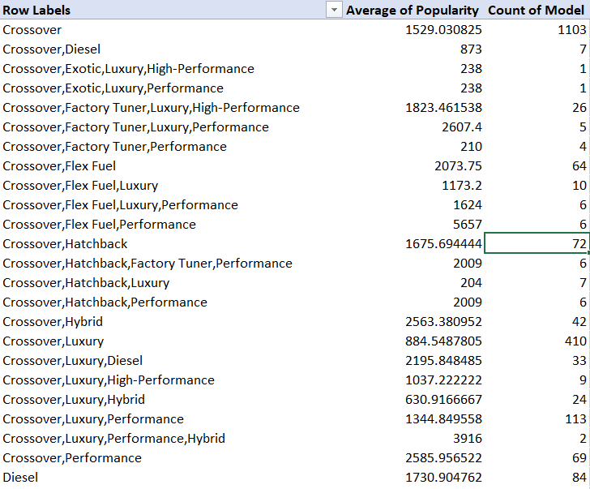

***I have only select the top of the result rest you can check in drive link.***

* **Task 1.B:** Create a combo chart that visualizes the relationship between market category and popularity.

**Insight Required:** What is the relationship between a car's engine power and its price?

* **Task 2:**  Create a scatter chart that plots engine power on the x-axis and price on the y-axis. Add a trendline to the chart to visualize the relationship between these variables.

**Insight Required:** Which car features are most important in determining a car's price?

* **Task 3:** Use regression analysis to identify the variables that have the strongest relationship with a car's price. Then create a bar chart that shows the coefficient values for each variable to visualize their relative importance.

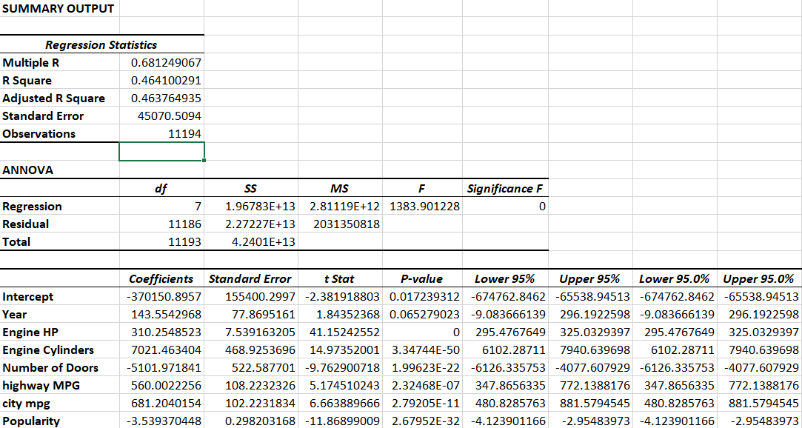

The most important features that determine the car features is engine cylinders that has the strong point which determine the car’s price.

**Insight Required:** How does the average price of a car vary across different manufacturers?

* **Task 4.A:** Create a pivot table that shows the average price of cars for each manufacturer.

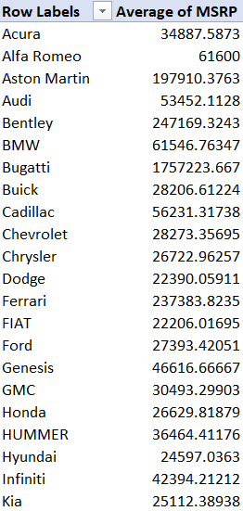

***I have only select the top of the result rest you can check in drive link.***

**Task 4.B:** Create a bar chart or a horizontal stacked bar chart that visualizes the relationship between manufacturer and average price.

**Insight Required:** What is the relationship between fuel efficiency and the number of cylinders in a car's engine?

* **Task 5.A:** Create a scatter plot with the number of cylinders on the x-axis and highway MPG on the y-axis. Then create a trendline on the scatter plot to visually estimate the slope of the relationship and assess its significance.
* **Task 5.B:** Calculate the correlation coefficient between the number of cylinders and highway MPG to quantify the strength and direction of the relationship.

To calculate the correlation I use the function **CORREL()** and correlation coefficient between the number of cylinders and highway MPG is = **-6.20312551**.



So in this case the value is negative, so as number of cylinders present in the car increases, then the estimated miles per gallon decreases.

## Building the Dashboard:

**Task 1:** How does the distribution of car prices vary by brand and body style?

**Task 2:** Which car brands have the highest and lowest average MSRPs, and how does this vary by body style?

that have the highest and lowest average MSRPs are Bugatti and Plymouth

Car brand having the highest average MSRPs is **Buggati** and the lowest average MSRPs is **Playmouth**.

**Task 3:** How do the different feature such as transmission type affect the MSRP, and how does this vary by body style?

The high price of a car varies by transmission type **automated manual** and the low price of a car varies by the transmission type **manual**.

**Task 4:** How does the fuel efficiency of cars vary across different body styles and model years?

The highest fuel efficiency of a car varies by the body style of are **4dr hatchback** and the lowest are **cargo van**.

**Task 5:** How does the car's horsepower, MPG, and price vary across different Brands?

**Results**

After completing this project, I have gained a deep understanding of various Excel tools and their practical applications in data analysis. I have extensively explored and analyzed data from rows and columns, utilizing a range of formulas and functions to derive meaningful insights.

By employing line charts, scatter charts, and column charts, I have been able to analyze trends in car features and pricing over time. This allowed me to identify patterns and fluctuations, providing valuable insights into market dynamics and consumer preferences.

And I delved into investigating the relationship between a car's features and its popularity. Using advanced Excel functions and techniques, I conducted in-depth analyses to uncover correlations and dependencies. Understanding which features drive consumer demand is crucial for product development and marketing strategies.

Overall, this project has equipped me with practical knowledge and skills in Excel, allowing me to analyze data effectively and extract valuable insights. I am now well-prepared to handle future data analysis tasks and contribute to optimizing pricing and product development decisions in various industries.

Thank-you